13. Dig the Data: Sort It Out
Steps to Create Your 30-minute Playlist in Excel Part 2
(Located on the remc.org/21things4students site)

Summary of spreadsheet actions for this part:
- Add additional data, up to 10 of your own favorite artists/songs with genre and length (appropriate for your school audience and setting).
- Copy selected data onto another sheet and name the sheet Playlist.
- Use a formula to calculate the total length of minutes and then seconds of your playlist.
- Add or delete songs so that the length of your Playlist is approximately 30 minutes.
Your task is to finalize your list of music choices for a playlist. You will create a new sheet to copy and paste your selections into and use formulas to create a 30-minute playlist. Note: The songs shown in the screenshots in these directions may not be identical to yours. These screenshots are shown as examples.
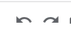
Remember you can use the undo and redo arrows for any errors.

Steps to create your playlist:
- On the Song Database, add up to 10 of your favorite song choices to the bottom of the list, including the artist, song title, genre, minutes, and seconds.
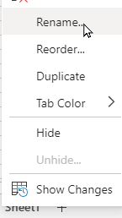
- Create a new sheet using the + and Rename it My Playlist by either doing a double-click on the new sheet name, or Right-click and choose Rename.
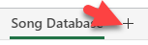

- Return to the Song Database and copy the headers in Row 1 and paste them on Row 1 of the Playlist sheet.
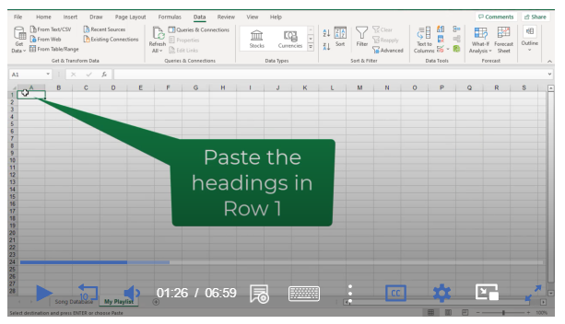
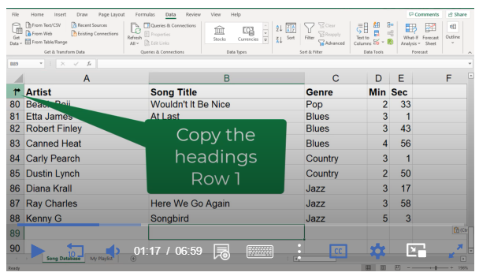
(Song database sheet) (Playlist sheet)

- Use a technique to make the column “fit” to the size of the contents.
  - Move your cursor over the divider line between the column names and when it becomes a line with two arrows, double-click to have the colum automatically resize to the contents of the column.
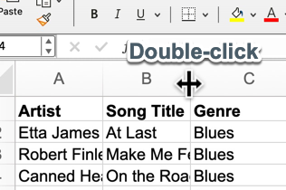
- On the Song Database (remember steps for sorting), sort as desired and then copy 10-12 of your favorites and paste them (one at a time) on the Playlist sheet below the headers.
*Suggestion: It might help to freeze the headers on your Playlist sheet. Select Row 1, use the View menu, and freeze the top row.
Using formulas to fine-tune your Playlist to 30 minutes:
- On the Playlist, place your cursor 5 or more rows below the last song in the D or Minutes Column.
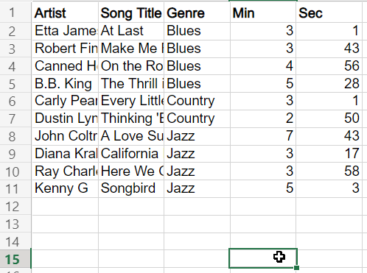
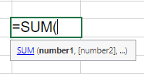
- Select Formulas on the main menu, then locate the Math and Trig Icon
and use the drop-down to scroll down to the word SUM (shown below)
Result: you will see =SUM(
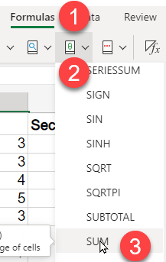
Now drag with your mouse from the first minutes down to the empty cell just before the cell with the formula and select Enter. It will show the total minutes in the column.
NOTE: If you are working in OneDrive online this will look a little different with a pop-up Arrange box (as shown in the video).
The total minutes should appear in either case.

- Now you want to get a total of seconds in column E.
Here’s a great formula feature:
To apply the formula to the Seconds column, hover your mouse over the SUM cell and look at
the bottom right corner of the cell for a dark square 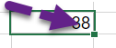
Put your cursor on that small square until it changes to a + and drag over to the right under the seconds column. You will see a total of the seconds appear.
9. Change the seconds into minutes.
To change the seconds into minutes we need to divide the formula by 60 (60 sec = 1 min). To do this go up to the formula bar 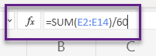 and type /60 at the end of the formula and press Enter.
You will now have a total of the seconds in minutes you can now use another formula to add these to the total minutes (or in your head).

- Get a Total for minutes and seconds.
Go one row down and into column C and Type Total Min 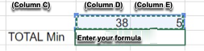
Put your cursor in the blank cell in Column D next to Total Minutes.
Go to the Formula menu>Math & Trig>SUM like before, but this time drag your mouse across the two totals in the row above. And press Enter.

- Final Step
If your total minutes are more than 30, then you will need to delete one or more songs until your total is 30 or less minutes.
If your total is less than 30 minutes, then you will need to pick another song (or songs) from the Song Database list and add (paste it) to your Playlist until you are close to 30 minutes.

The last activity of this Quest is to learn about Filters.
Congratulations on creating your playlist.

